**Industrial farm us of antibiotics versus sustainable farming[1]**

Industrial farm use of antibiotics began in the 1970’s for the purpose of 1) disease prevention, 2) disease control, 3) disease treatment and 4) production which reduces the microflora in the animal digestive system (that would normally consume ingested feed) that has the effect of reducing the amount of animal feed needed, as well as increasing production volume. Increased public awareness is causing more research into a more organic sustainable farming with a larger percent of the public being more willing to pay more for organic raised meat. The use of antibiotics is researched by the FDA, CDC.

The public concerns are the antibiotic residue from animal products that enters the human food system and the antibiotic resistant bacteria that became noticeably increased shortly after antibiotics were introduced into factory farms.

That antibiotic resistant bacteria have influence in the human population is not in question scientifically, how exactly the transmission occurs is a matter of debate. Each time antibiotics are fed to farm animals or ingested by humans, antibiotic resistant bacteria strains occur. Approximately 80% of antibiotics sold are for farm animals (Loglisci, 2010) making this a significant contributory factor. Changing the way antibiotics are administered to humans and animals is being researched for how adjustments can be made.

There are three main routes of transmission: 1) drug resistant bacteria in farm animals are ingested by humans in several ways, 2) humans come into direct contact with farm animals, 3) infected people can transmit the disease to others.

It is difficult to measure the volume of antibiotics administered since they are mostly fed to animals through feed that is controlled by farmers nor often do they know the details. One way of measuring the effects is to determine the longer term perspective and the existence of antibiotic resistant bacteria like MRSA () also known as the ‘Super Bug’.

Public opinion has changed since antibiotics were first introduced into factory farms with current analysis showing a much lower positive effect than with previous studies. Denmark has stopped feeding antibiotics to their farm animals for over 10 years. The measurement of MRSA cases per capita population is a litmus test of how policy changes are effectively reducing antibiotic use in both human ingestion and factory farm use. If the MRSA resistance cases show a smaller percent per population, a direct link can be shown to the countries antibiotic policies for both human and animal consumption.

Here are four graphs for years 2001, 2005, 2011 and 2013 for the U.S., UK, France, Denmark, India, Thailand, and Greece.

* Denmark has only a 1-2 percent of antibiotic resistant MRSA virus which reflects a ban on using antibiotics in farm animals.
* The U.S. (FDA) enacted restrictions in 2012 in antibiotic use for production purposes but they are voluntary. The difference between 2001 and 2013 is .47 to .44.
* The UK’s rate was .46 in 2001 and .14 in 2013 which is a significant improvement. Their policies are a guidance only
* India antibiotic resistant MRSA cases have increase from .39 to .53. Their 2011 law encouraged reduction of antibiotic use for farm animals.
* Thailand .25 to .22
* Greece .50 to .39
* India .34 to .36

Denmark has the lowest MRSA cases and a ban on antibiotics. The other countries have largely voluntary guidance policies to encourage the reduction of antibiotic use in farm animals. The strongest encouragement is through consumers making better choices and purchasing farm products produced without antibiotics. The example of Denmark’s low number of MRSA cases is the best model.

For having some of the best research and one of the highest living standards, the U.S. has one of the highest MRSA cases per capita. Although consumers can make the best choice by purchasing farm products grown without antibiotics, MRSA in the U.S. population in general means that each consumer still has a high exposure rate regardless of their personal choices.

***How antibiotic resistance occurs from the animal to human population***

<https://cddep.org/sites/default/files/swa_2015_final.pdf>

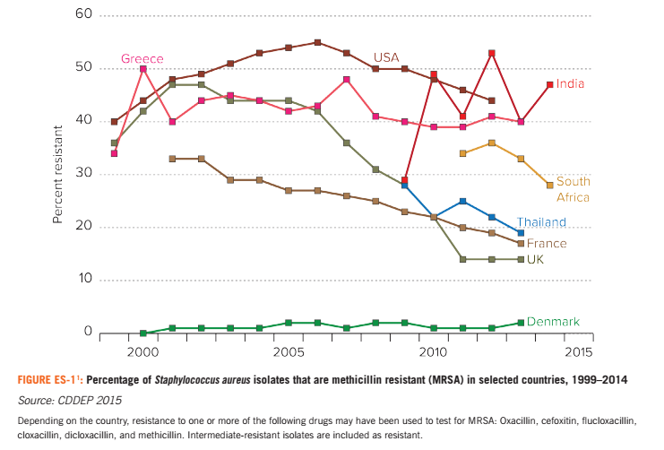

References:

Loglisci, R. 2010. “New FDA numbers reveal food animals consume lion’s share of antibiotics.” Johns Hopkins Bloomberg School of Public Health’s Center for a Livable Future blog. http://www.livablefutureblog.com/2010/12/ new-fda-numbers-reveal-food-animals-consume-lion%E2%80%99s-share-of-antibiotics

1. Stacy Sneeringer, James MacDonald, Nigel Key, William McBride, and Ken Mathews. Economics of Antibiotic Use in U.S. Livestock Production, ERR-200, U.S. Department of Agriculture, Economic Research Service, November 2015